PET STORE API

CREATE:-

<http://localhost:8878/ps/create>

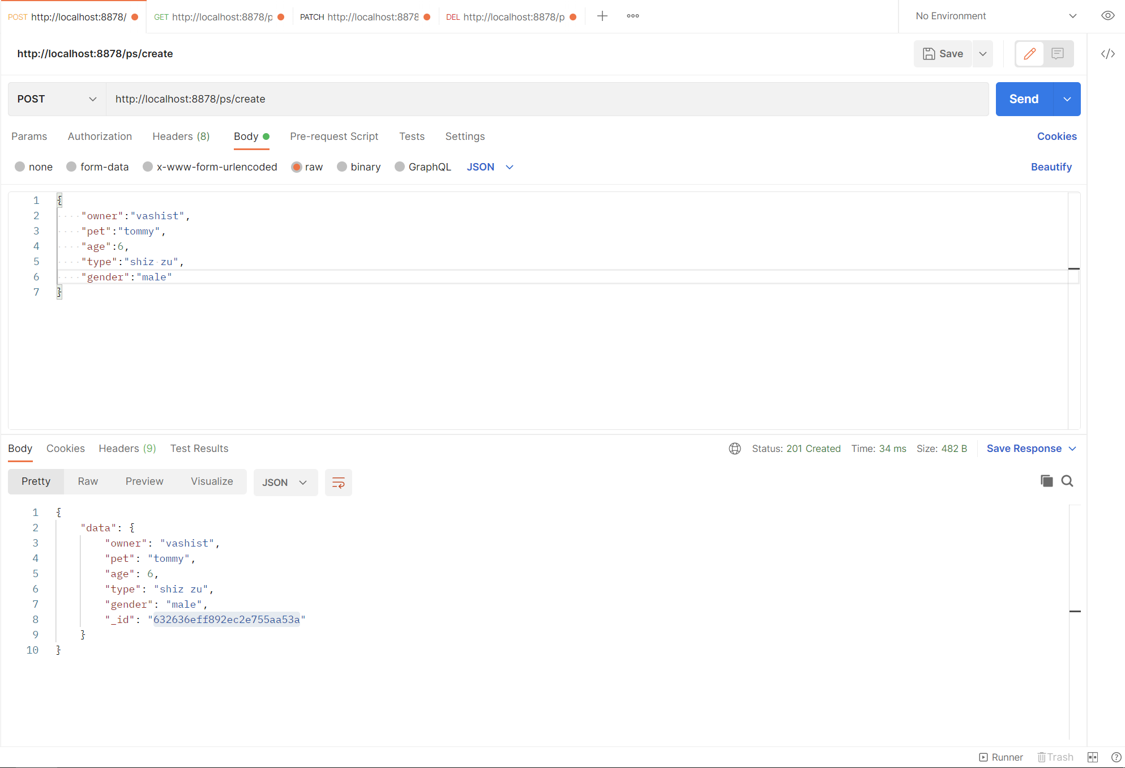

READ:-

<http://localhost:8878/ps/get/>

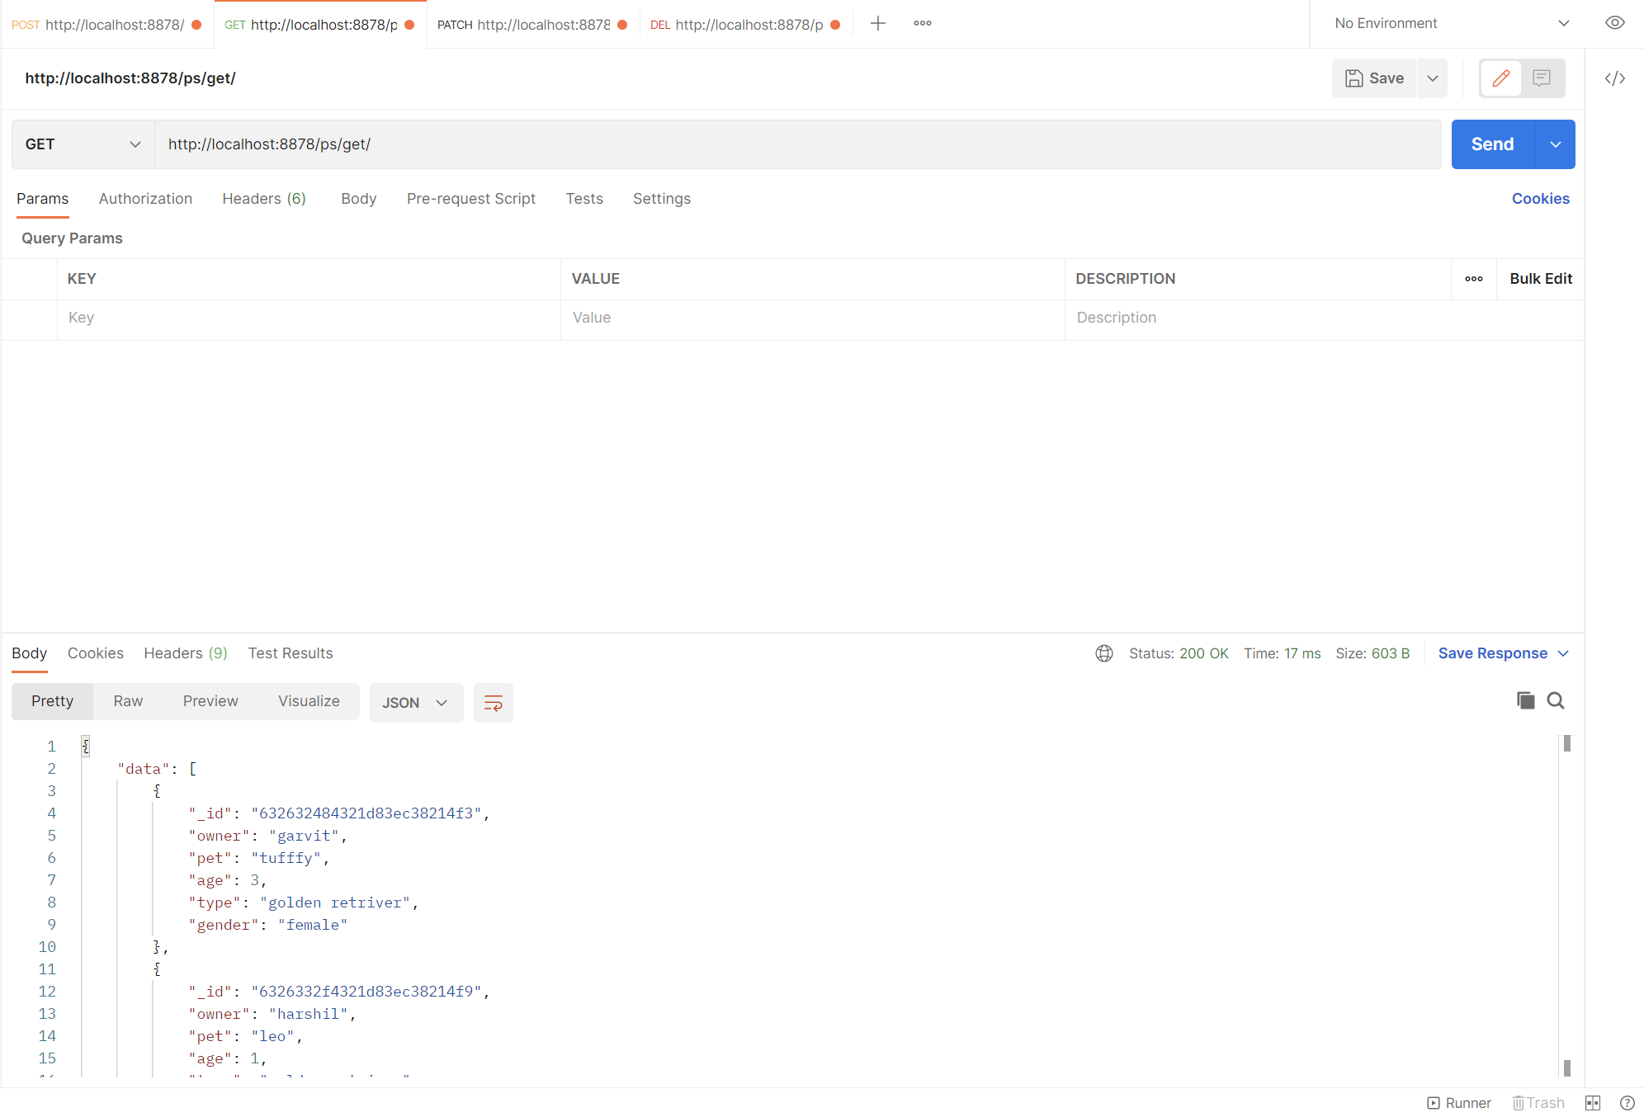

UPDATE:-

http://localhost:8878/ps/update/632636eff892ec2e755aa53a(PETID)

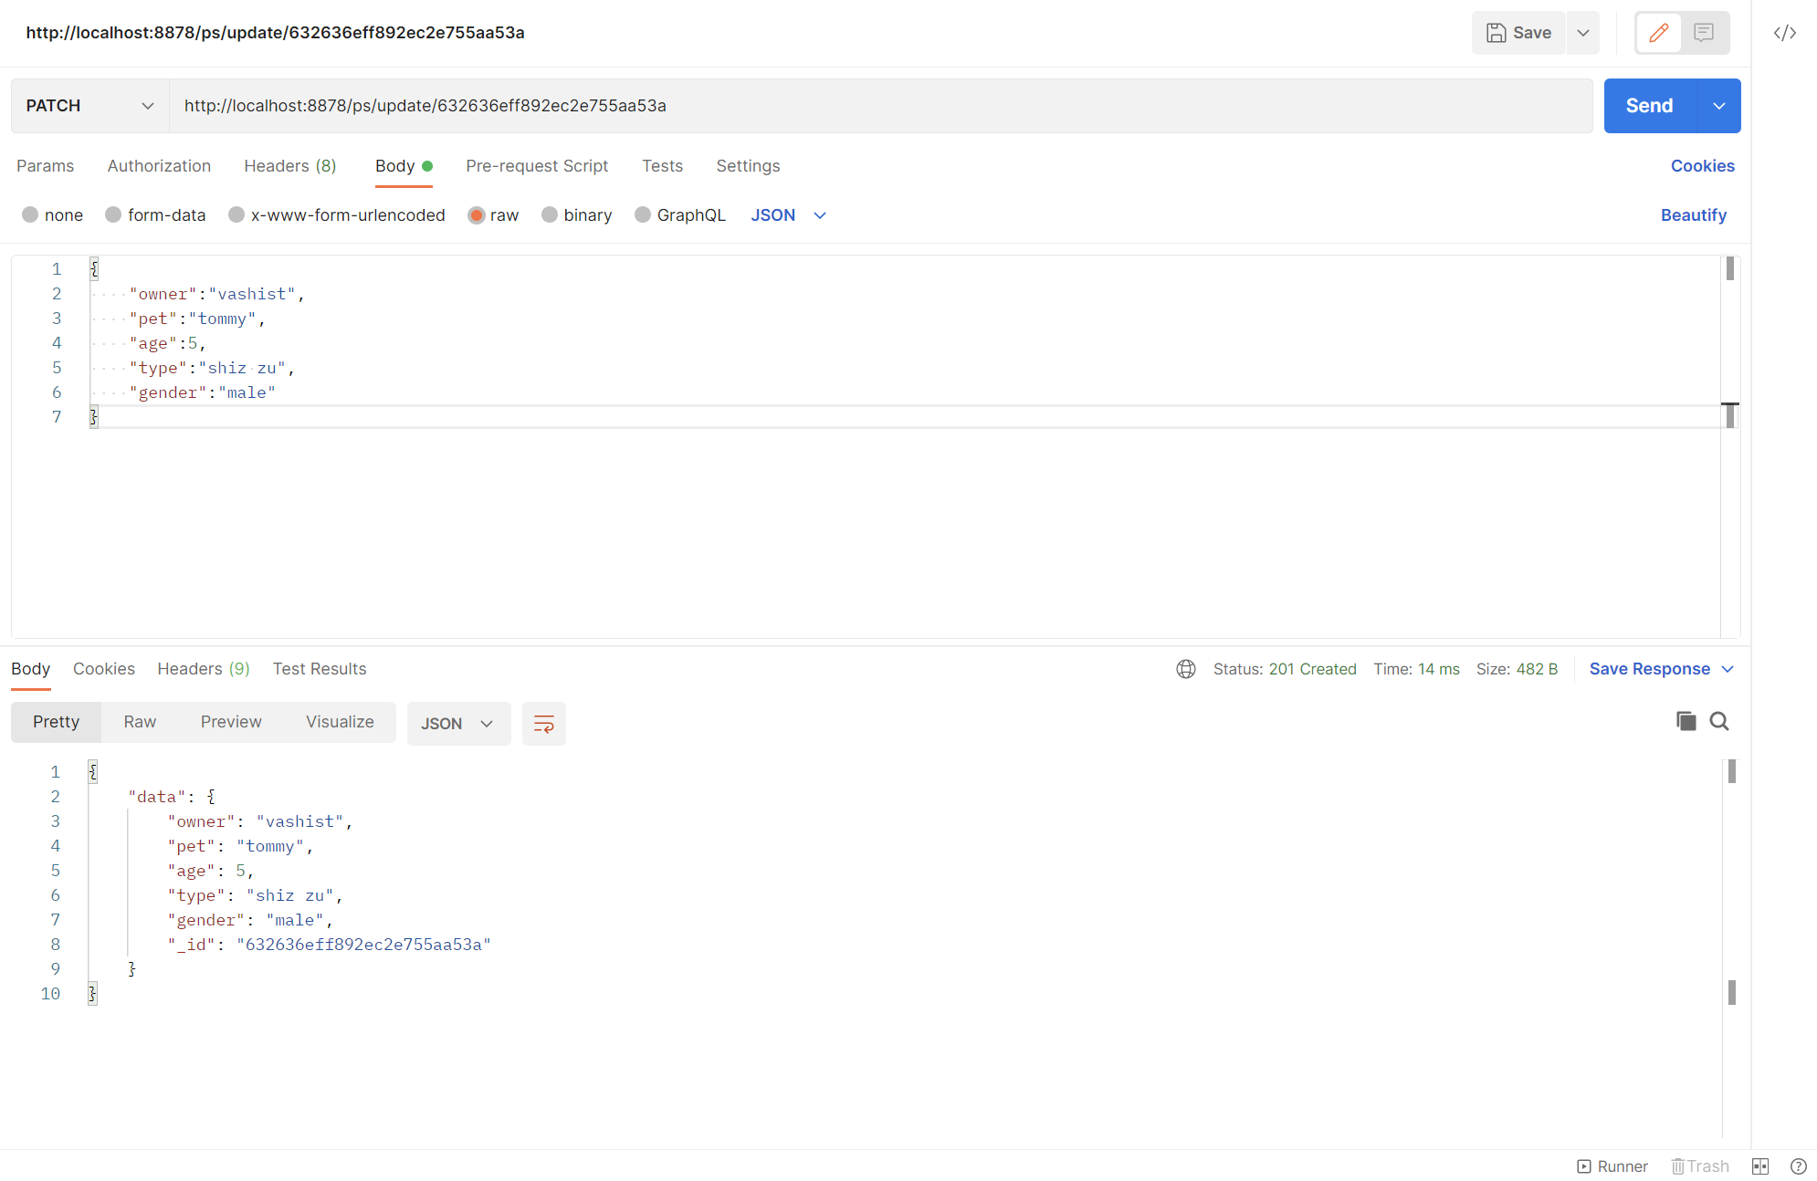

DELETE:-

<http://localhost:8878/ps/delete/632636eff892ec2e755aa53a(PETID)>

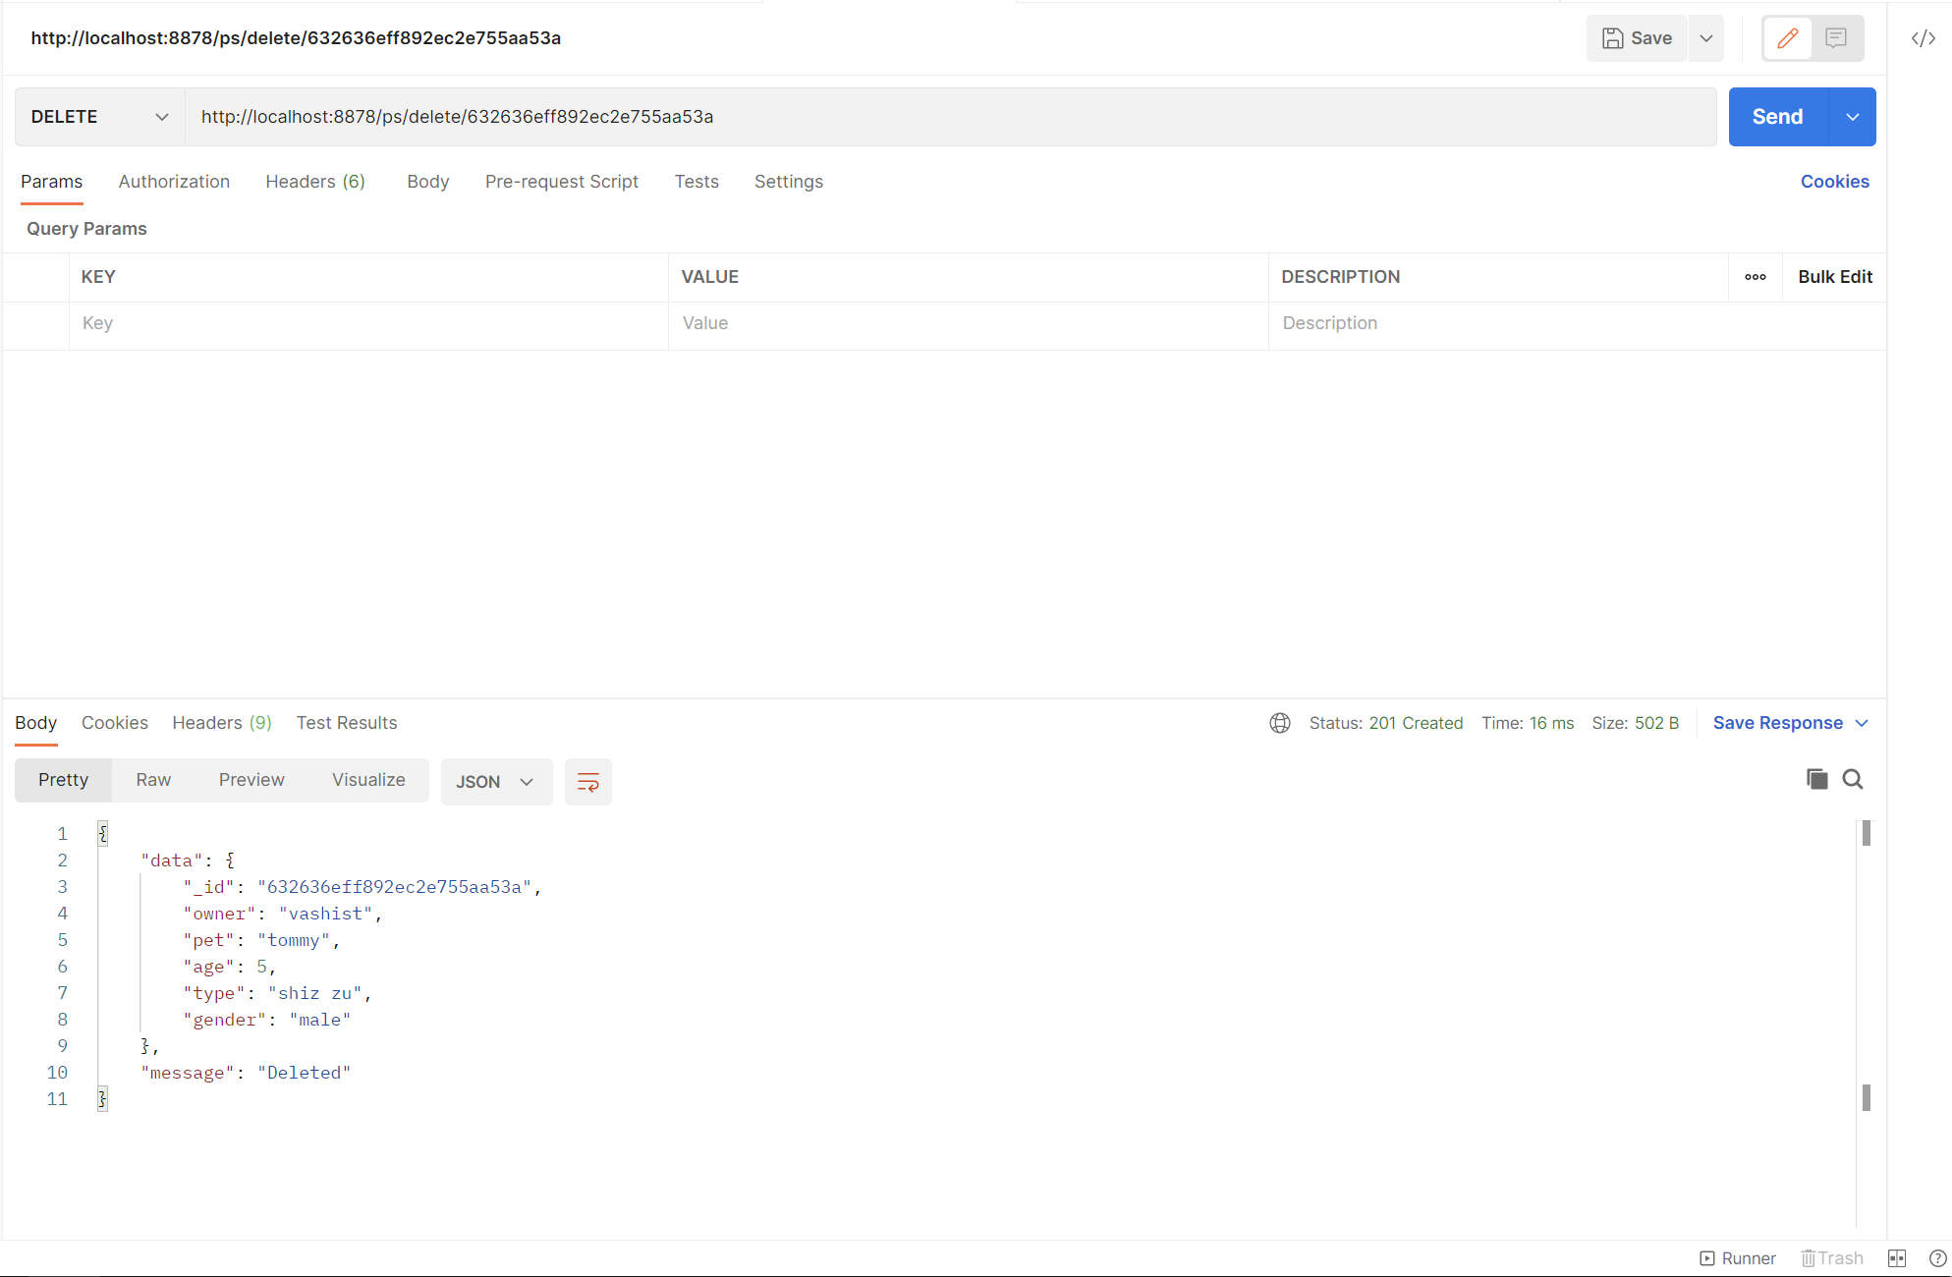

MADE BY HARSHIL CHOUDHARY :D